ISA BUS
(Industry Standard Architecture)

CONTENTS

- What is BUS?
- What is ISA BUS?
- ISA Pinout
- Read Operation of ISA
- Bus Structure of Intel 486
- Bus Structure of Intel Pentium
a. North Bridge
b. South Bridge
- Isa Bus Interrupt System
- 8259A Programmable Interrupt Controller
a. The meaning of 8259a’s the other connections
- Elimination of ISA Bus
- Sources

CAHİT TARIK GENÇ
042403021
Computer Technology and Programming
Izmir University of Economics

13.01.2007

ISA BUS
(Industry Standard Architecture)

1- What is BUS:
A bus connects all the internal computer components to the CPU and Main memory. A fast bus allows data to be transferred faster, which makes applications run faster. On PCs, the old ISA bus is being replaced by faster buses such as PCI. There are two types of bus; System Bus, I/O Bus.
- System Bus: Connecting to CPU, memory and Cache. Address Bus, Data Bus, Control Bus.
- I/O Bus: Connecting to the above three buses is the "good old" standard I/O bus, used for slower peripherals (mice, modems, regular sound cards, low-speed networking) and also for compatibility with older devices. On almost all modern PCs this is the Industry Standard Architecture (ISA) bus. ISA, Micro Channel (MCA), EISA, VESA Local bus (VL-bus), PCI Local bus, AGP, PC-Card (PCMCIA), USB, Fire Wire (IEEE-1394)

2- ISA BUS:
In 1982 when ISA BUS appeared on the first PC the 8-bit ISA bus ran at a modest 4.77 MHZ – the same speed as Intel 8088. ISA BUS is extremely slow by today's standards and not suited to the use of a graphical operating system like Windows.
In 1984 the IBM AT was introduced using the Intel 80286; at this time the bus was doubled to 16 bits (the 80286's data bus width) and increased to 8 MHz (the maximum speed of the original AT, which came in 6 MHz and 8 MHz versions and 24 address lines).
ISA Bus is used with sound cards, disk drives or most network and video cards.

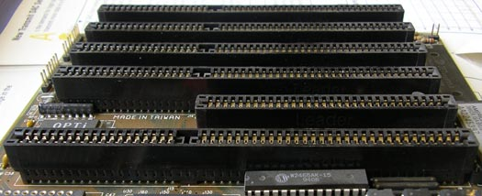

3- ISA Pinout:

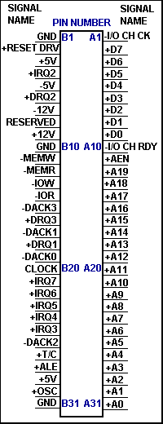

In the figure you can see the pinouts of the ISA BUS. The BUS is divided into two sides. The first side pins are named A1 to A31 and it is the components side. It consists of the address and data buses. The second side pins are named B1 to B31 and it is the solder side. This side contents the power pins and the signals related to interrupts and DMA transfers.

4- Read operation of the ISA:
CPU sends out a high on the ALE signal then sends out the A0-A19 lines. On the address of the target port to be read will be latched. Then the BUS takes the -IOR signal to a low level. So the addressed device will take a data byte to the D0-D7 data bus. The microprocessor will read then the data bus and take the -IOR signal to a high again. The only difference between a memory read/write cycle and a port read/write cycle is that in a memory cycle the -MEMR and -MEMW signals will be asserted, working the same way as -IOR and -IOW do.

5- Bus Structure of Intel 486:

Local bus is faster than ISA Bus. ISA Bus gets data from Local Bus at two or four cycles. This reduces system performance.

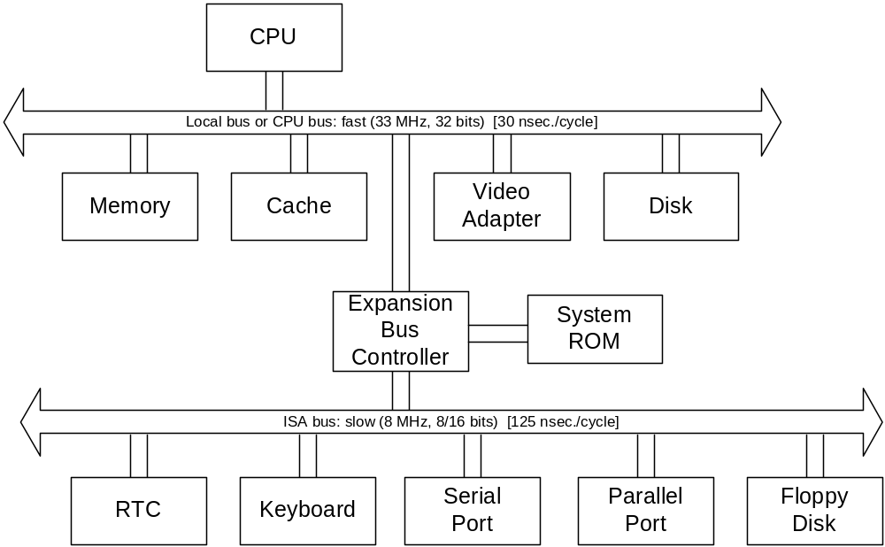
ISA Controller

6- Bus Structure of Intel Pentium:
PCI bus is faster than ISA Bus. PCI Bus gets data from CPU Bus at two cycles. This way is used now.

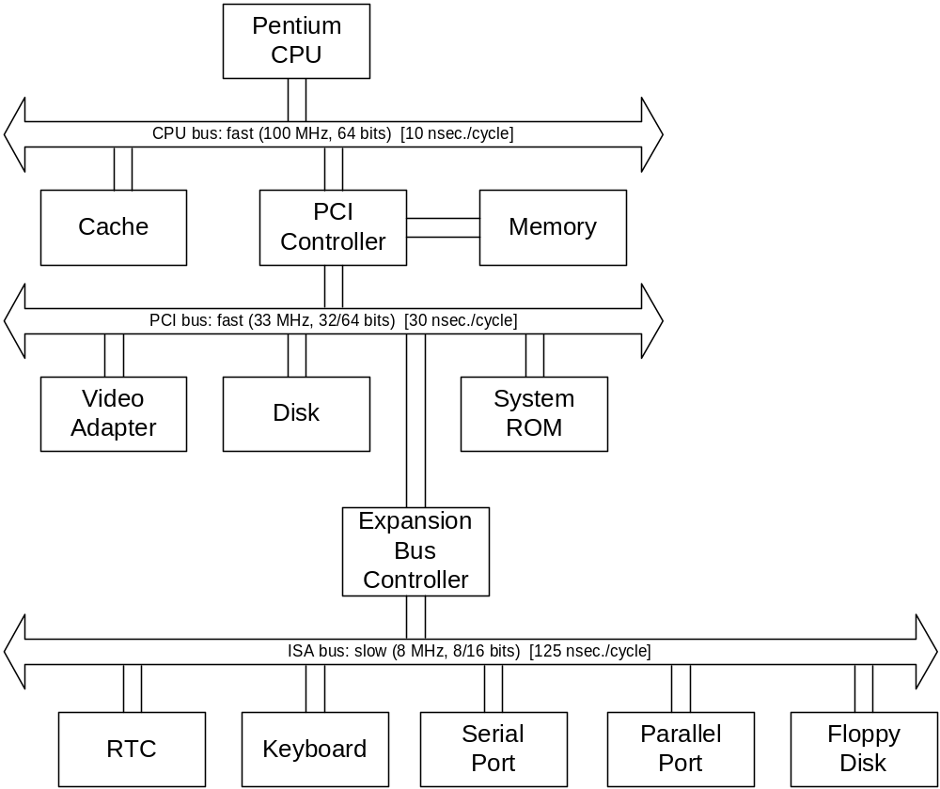
South Bridge
North Bridge

- North Bridge:

The North Bridge, also known as the Memory Controller Hub (MCH), is traditionally one of the two chips in the core logic chipset on a PC motherboard, the other being the Southbridge. Separating the chipset into Northbridge and Southbridge is common.

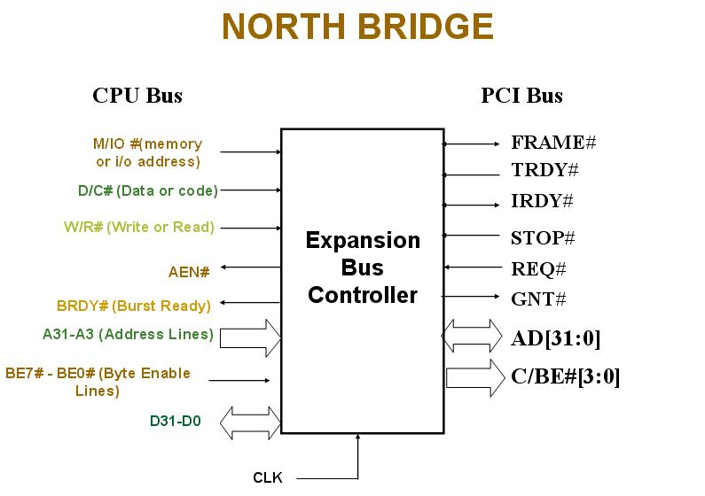

The North Bridge typically handles communications between the CPU, RAM, AGP or PCI Express, and the South Bridge. Different processors and RAM require different signaling, a North Bridge will typically work with only one or two classes of CPUs and generally only one type of RAM.

- South Bridge:
South Bridge, also known as the I/O Controller Hub (ICH), is a chip that implements the "slower" capabilities of the motherboard in a North Bridge / South Bridge chipset computer architecture. The South Bridge can usually be distinguished from the North Bridge by not being directly connected to the CPU. Rather, the North Bridge ties the South Bridge to the CPU.

The South Bridge is further removed from the CPU, it is given responsibility for the slower devices on a typical microcomputer. A particular South Bridge will usually work with several different North Bridges, but these two chips must be designed to work together; there is no industry wide standard for interoperability between different core logic chipset designs. Traditionally this interface between North Bridge and South Bridge was simply the PCI bus, however since this created a performance bottleneck, most current chipsets use a different (often proprietary) interface with higher performance.

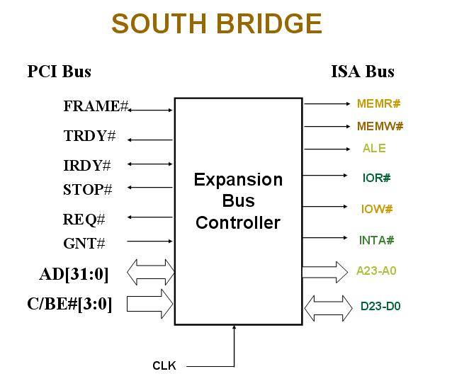
For example when CPU Bus sends an address with address lines to North Bridge, PCI Bus via “AD” line sends the address to South Bridge and South Bridge translates the address then ISA Bus gets the address via A23-A0.

7- ISA Bus Interrupt System:

- 16-bit ISA bus chains two 8259As together.
- IRQ 9 is used to re-route anything trying to use IRQ 2.
- Incorporated in chip set.

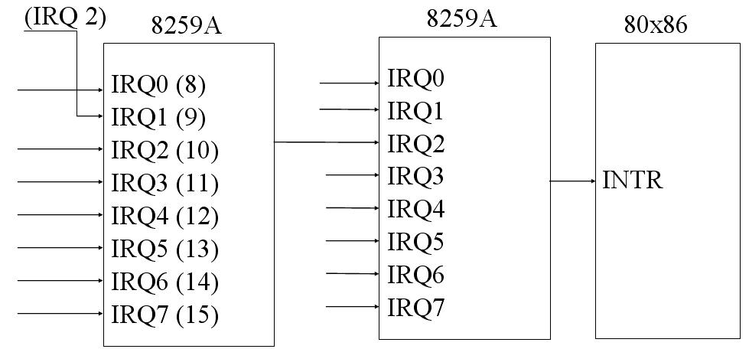

8- 8259A Programmable Interrupt Controller:

- The 8259A adds 8 vectored priority encoded interrupts to the microprocessor.
- It can be expanded to 64 interrupt requests by using one master 8259A and 8 slave units.

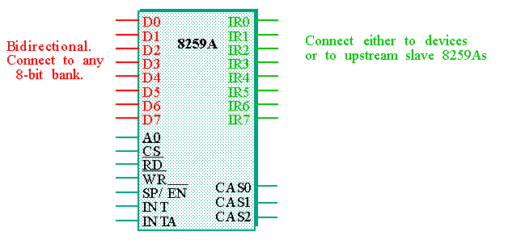

a- The meaning of 8259a’s the other connections:

- WR
Connects to a write strobe signal (one of 8 for the Pentium).
- RD
Connects to the IORC signal.
- INT
Connects to the INTR pin on the microprocessor.
- INTA
Connects to the INTA pin on the microprocessor.
- A0
Selects different command words in the 8259A.
- CS
Chip select - enables the 8259A for programming and control.
- SP/EN
Slave Program (1 for master, 0 for slave)/Enable Buffer (controls the data bus transceivers when in buffered mode).
- CAS2-CAS0
Used as outputs from the master to the slaves in cascaded systems.

9- Elimination of ISA Bus:

- ISA Bus is slow, hard to use and bulky.
- ISA plug in cards to be replaced by either PCI plug-in cards or USB add-on peripherals
- Limited number of interrupts.
- No central registry.
- The ISA bus is limited to 24 bits of address. 2^24 = 16MB. It means that an ISA card that uses DMA cannot physically access memory beyond 16MB of RAM. This is a limitation of the ISA bus.
- Motherboard gets 32-bit data from ISA BUS at two times. Meanwhile at this time ISA BUS declares “wait state” to the motherboard. Therefore ISA BUS may reduce System Performance.
- If a ISA based controller card such as Ultra SCSI - 40Mb / sec or SCSI-2 Fast - 10Mb / sec are used, we can expect no more than an 8Mb per second transfer rate from your controller card.
- PCI cards have “Plug and Play” technology and can configure themselves, so Operating Systems distinguish them.
- ISA cards are more cumbersome to install than other cards because I/O addresses, interrupts and clock speed must be set using jumpers and switches on the card itself.

10- Sources:

http://linuxgazette.net/124/dutta.html

http://www.auditmypc.com/acronym/ISA.asp

http://www.ctv.es/pckits/tISA.html

http://www.pctechguide.com/12Interfaces_PCI_bus.htm

http://www.cs.cmu.edu/afs/cs.cmu.edu/academic/class/15347-s98/public/lectures/lect10.ppt

